<option value="">1991</option>

<option value="">2024</option>

<option value="">2025</option>

<option value="">2026</option>

<option value="">2027</option>

<option value="">2028</option>

<option value="">2029</option>

<option value="">2030</option>

</select>

<p> Gender </p>

<label class="gen">Female<input type="radio" > </label>

<label class="gen">Male<input type="radio" > </label> <br><br>

<small>By clicking sign Up you agree to our Terms Data policy and cookie policy you recive SMS <br>notification from us and can opt out any time</small><br>

<button style="color:white; font-size: large;background-color:green;margin-left: 15%;border-radius: 10%;border-color: green;width:20% ; " >Sign up</button>

</div></body></html>

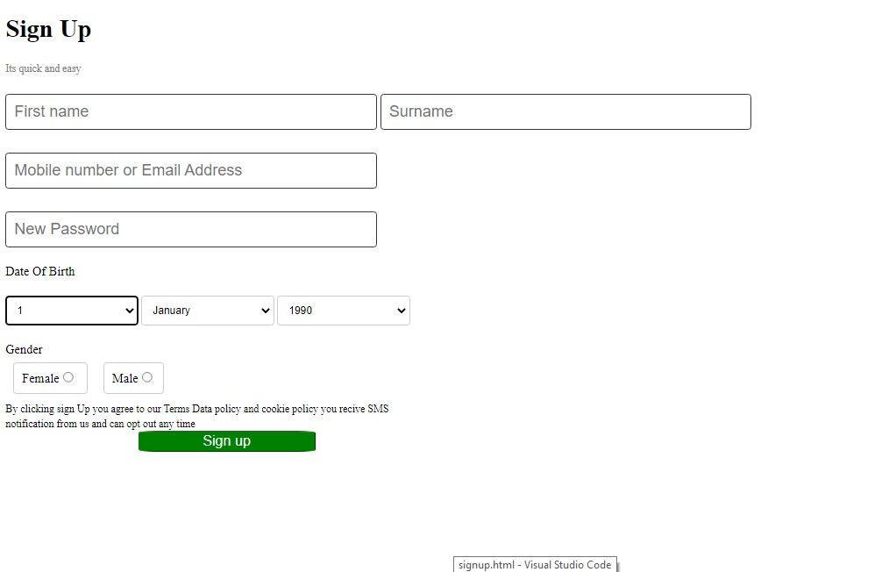

<option value="">18</option>

<option value="">19</option>

<option value="">1992</option>

<option value="">1993</option>

<option value="">1994</option>

<option value="">1995</option>

<option value="">1996</option>

<option value="">1997</option>

<option value="">1998</option>

<option value="">1999</option>

<option value="">2001</option>

<option value="">2002</option>

<option value="">2003</option>

<option value="">2004</option>

<option value="">2005</option>

<option value="">2006</option>

<option value="">2007</option>

<option value="">2008</option>

<option value="">2009</option>

<option value="">2010</option>

<option value="">2011</option>

<option value="">2012</option>

<option value="">2013</option>

<option value="">2014</option>

<option value="">2015</option>

<option value="">2016</option>

<option value="">2017</option>

<option value="">2018</option>

<option value="">2019</option>

<option value="">2020</option>

<option value="">2021</option>

<option value="">2022</option>

<option value="">2023</option>

<option value="">20</option>

<option value="">21</option>

<option value="">22</option>

<option value="">23</option>

<option value="">24</option>

<option value="">25</option>

<option value="">26</option>

<option value="">27</option>

<option value="">28</option>

<option value="">29</option>

<option value="">30</option>

<option value="">31</option>

</select>

<select name="date" id="date">

<option value="">January</option>

<option value="">February</option>

<option value="">March</option>

<option value="">April</option>

<option value="">May</option>

<option value="">June</option>

<option value="">July</option>

<option value="">August</option>

<option value="">September</option>

<option value="">October</option>

<option value="">November</option>

<option value="">December</option>

</select>

<select name="date" id="date">

<option value="">1990</option>